**COMPUTER GRAPHICS LAB FILE**



**SUBMITTED BY:**

**NAME: ZISHNENDU SARKER**

**ROLL: 2K19/C0/450**

**SECTION : A6**

**COMPUTER GRAPHICS LAB (B2, G1)**

**SUBMITTED TO :**

**RAJU KUMAR SIR**

**DEPARTMENT OF COMPUTER SCIENCE &ENGINEERING**

***VISION***

Department of Computer Science & Engineering to be a leading world class technology department playing its role as a key node in national and global knowledge network, thus empowering the computer science industry with the wings of knowledge and power of innovation.

***MISSION***

The Mission of the department is as follows:  
  
1. To nurture talent of students for research, innovation and excellence in the field of computer engineering starting from Under graduate level.  
  
2. To develop highly analytical and qualified computer engineers by imparting training on cutting edge technology.  
  
3. To produce socially sensitive computer engineers with professional ethics.  
  
4. To focus on R&D environment in close partnership with industry and foreign universities.  
  
5. To produce well-rounded, up to date, scientifically tempered, design-oriented engineer and scientists capable of lifelong learning

INDEX:

|  |  |  |
| --- | --- | --- |
| Lab No. | Lab Assignment Name | Page |
| 01. | Write a program to draw basic output primitives | 4 |
| 02. | Write a program to implement DDA line drawing algorithm. | 5 |
| 03. | Write a program to implement Bresenham's line drawing algorithm. | 8 |
| 04. | WAP to implement Mid Point Circle Drawing Algorithm | 11 |
| 05. | WAP to implement Mid Point Ellipse drawing Algorithm | 13 |
| 06. | WAP to implement the Boundary fill algorithm | 15 |
| 07. | WAP to implement the Flood fill algorithm | 18 |
| 08. | WAP to implement the Translation an object | 20 |
| 09. | WAP to implement the Rotation an object | 21 |
| 10. | WAP to implement the Scaling an object | 25 |
| 11. | WAP to implement Reflection an object | 27 |
| 12. | Write a program to implement Cohen Sutherland Line Clipping Algorithm | 29 |

**LAB ASSIGNMENT NO. 01**

**Question :- Write a** **program to draw basic output primitives ( pixel, line, circle , rectangle, eclipse ).**

**Code:**

#include<conio.h>

#include<graphics.h>

int main()

{

int gd=DETECT,gm;

initgraph(&gd,&gm,(char*)"");

line(200,100,300,300);

circle(300,150,20);

putpixel(100,50,4);

rectangle(300,150,240,240);

ellipse(300,240,0,720,150,70);

getch();

closegraph();

return 0;

}

**Output:**

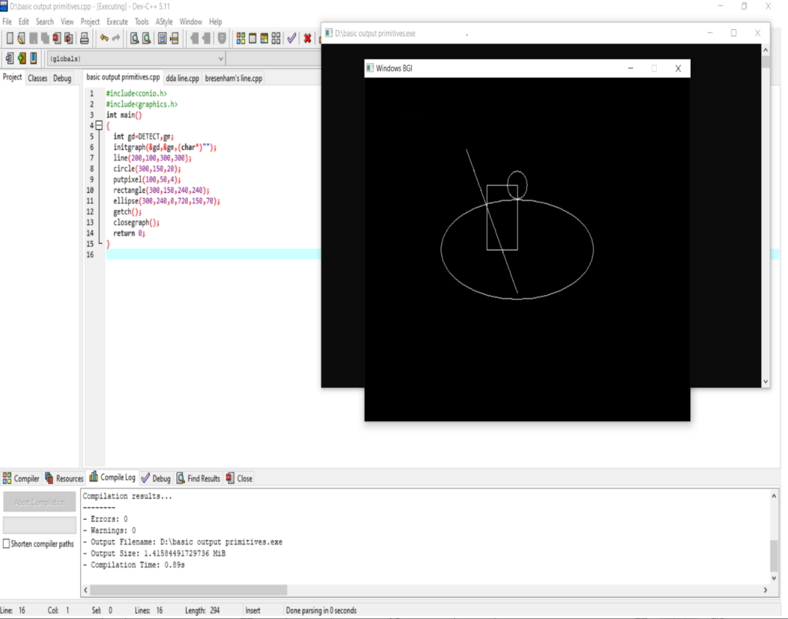

**LAB NO. 2**

**Question : Write a program to implement DDA line drawing algorithm.**

**Code:**

#include <graphics.h>

#include <iostream>

#include <math.h>

#include <conio.h>

int main()

{

float x,y,x1,y1,x2,y2,dx,dy,step;

std::cout<<"X1 is ";

std::cin>>x1;

std::cout<<" and "<<'\n'<<"X2 is ";

std::cin>>x2;

std::cout<<'\n'<<"Y1 is ";

std::cin>>y1;

std::cout<<" and "<<'\n'<<"Y2 is ";

std::cin>>y2;

int gd=DETECT,gm;

initgraph(&gd,&gm,(char*)"");

dx=abs(x2-x1);

dy=abs(y2-y1);

if(dx>=dy)

{

step=dx;

}

else

{

step=dy;

}

dx=dx/step;

dy=dy/step;

x=x1;

y=y1;

for(int i=1;i<step;i++)

{

putpixel(x,y,1);

x=x+dx;

y=y+dy;

}

getch();

closegraph();

return 0;

}

**OUTPUT:**

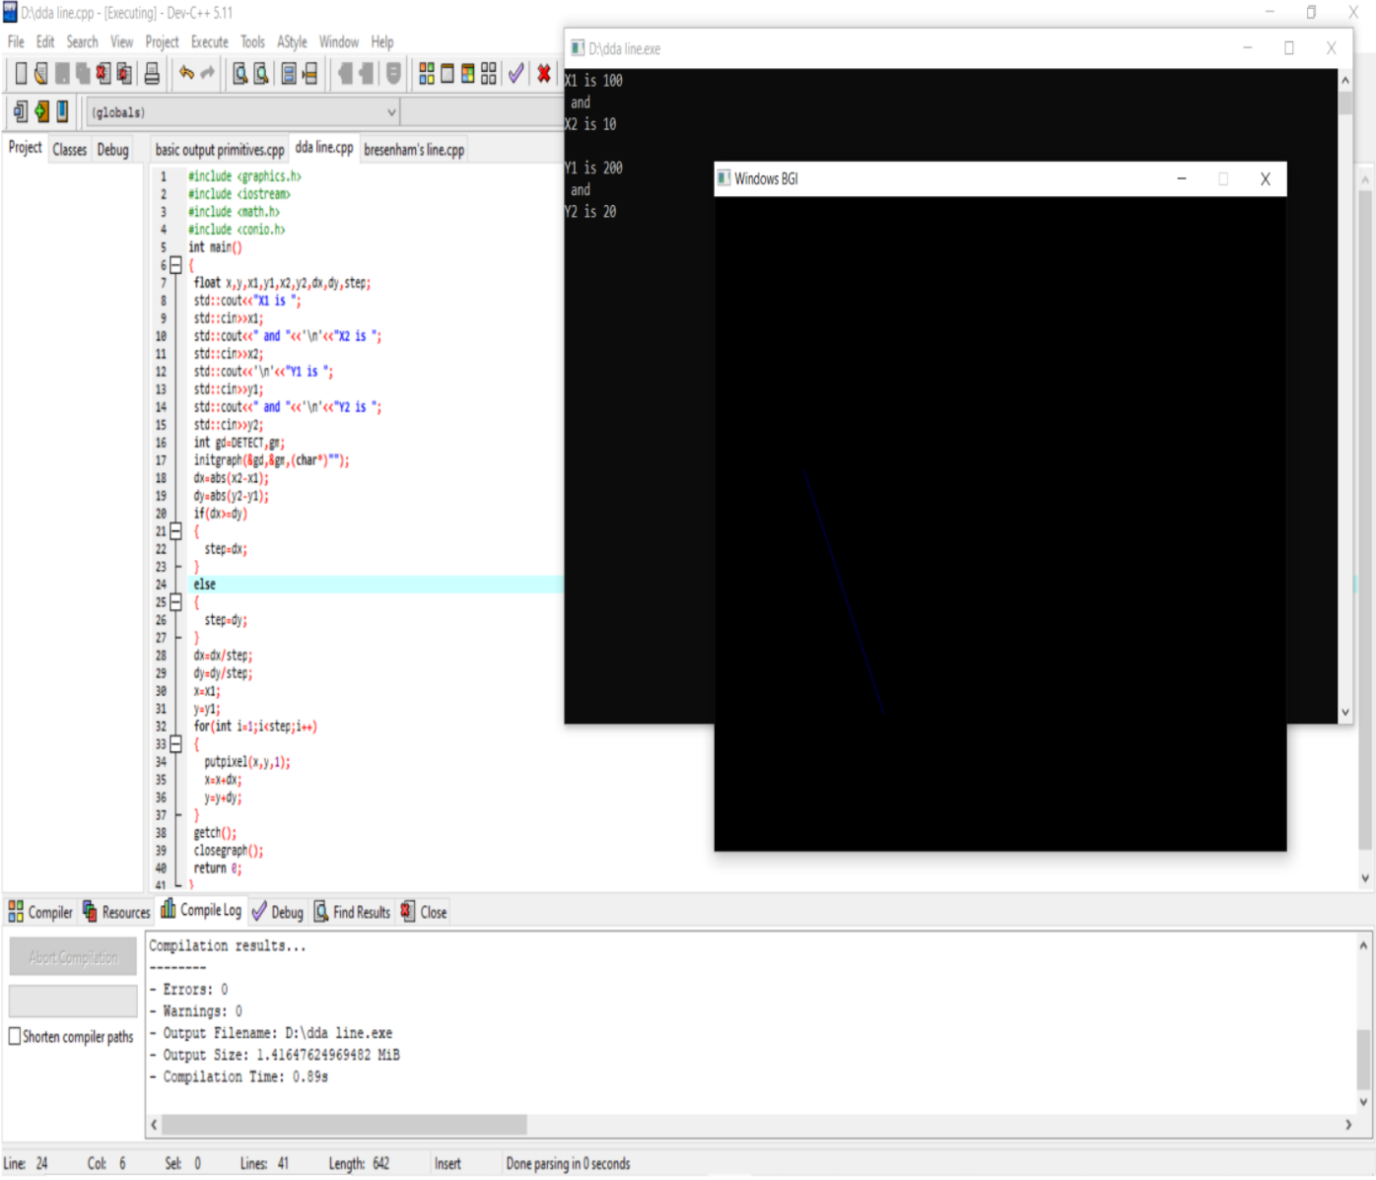

**LAB NO .3**

**Question :- Write a program to imlement Bresenham's line drawing algorithm.**

**Code:**

#include <iostream>

#include <graphics.h>

#include <conio.h>

int main()

{

int x,y,x1,y1,x2,y2,dx,dy,P;

std::cout<<"X1 is ";

std::cin>>x1;

std::cout<<" and "<<'\n'<<"X2 is ";

std::cin>>x2;

std::cout<<'\n'<<"Y1 is ";

std::cin>>y1;

std::cout<<" and "<<'\n'<<"Y2 is ";

std::cin>>y2;

int gd=DETECT,gm;

initgraph(&gd,&gm,(char*)"");

dx=(x2-x1);

dy=(y2-y1);

x=x1,y=y1;

if(dx>dy)

{

P=2*dy - dx;

while(x<=x2)

{

putpixel(x,y,3);

if(P<0)

{

P=P+2*dy;

x+=1;

}

else

{

P=P+2*dy-2*dx;

x+=1;

y+=1;

}

}

}

if(dx<dy)

{

P=2*dx-dy;

while(y<=y2)

{

putpixel(x,y,3);

if(P<0)

{

P=P+2*dx;

y+=1;

}

else

{

P=P+2*dx-2*dy;

x+=1;

y+=1;

}

}

}

if(dx==dy)

{

while(x<=x2)

{

putpixel(x,y,3);

x+=1;

y+=1;

}

}

getch();

closegraph();

return 0;

}

**OUTPUT:**

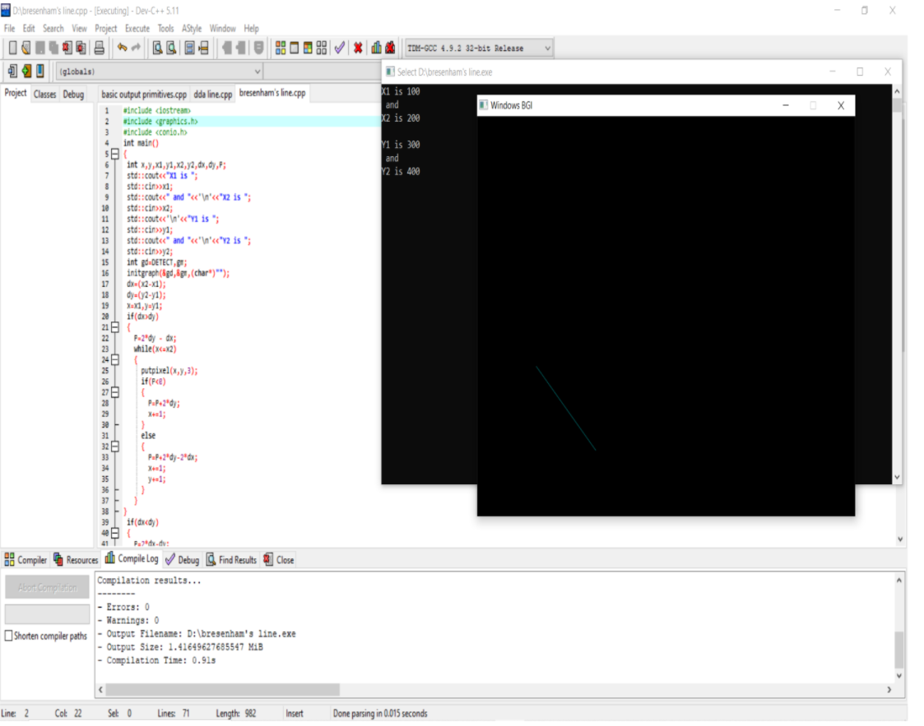

**LAB ASSIGNMENT NO. 04**

**QUESTION:- WAP to implement Mid Point Circle Drawing Algorithm.**

**CODE:**

#include<conio.h>

#include<graphics.h>

#include<iostream>

int main()

{

int x,y,x_mid,y_mid,r,d;

int g_mode,g_driver=DETECT;

initgraph(&g_driver,&g_mode,(char*)””);

std::cout<<”enter the coordinates=”;

std::cin>>x_mid>>y_mid;

std::cout<<”\n now enter the radius=”;

std::cin>>r;

x=0;

y=r;

d=l-r;

do

{

putpixel(x_mid+x,y_mid+y,1);

putpixel(x_mid+y,y_mid+x,1);

putpixel(x_mid-y,y_mid+x,1);

putpixel(x_mid-x,y_mid+y,1);

putpixel(x_mid-x,y_mid-y,1);

putpixel(x_mid-y,y_mid-x,1);

putpixel(x_mid+y,y_mid-x,1);

putpixel(x_mid+x,y_mid-y,1);

if(d<0) {

d+=(2*x)+1;

}

else{

y=y-1;

d+=(2*x)-(2*y)+1;

}

x=x+1;

}while(y>x);

getch();

}

**OUTPUT:**

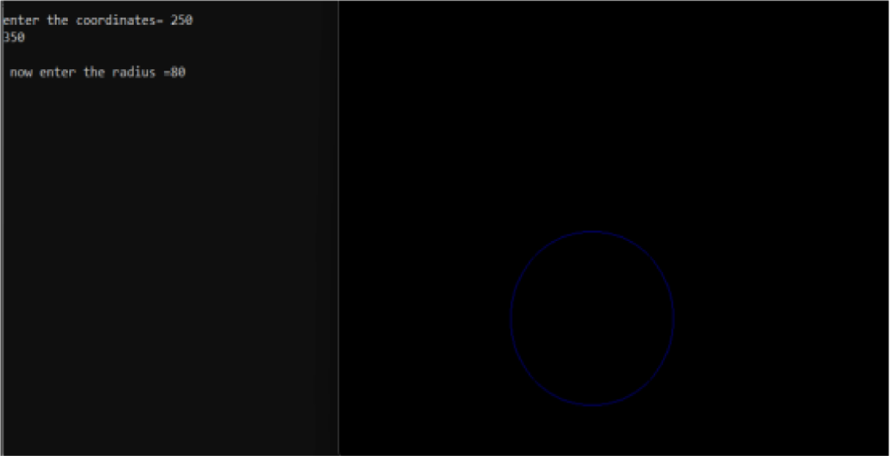

**LAB ASSIGNMENT NO. 05**

**QUESTION:- WAP to implement Mid Point Ellipse drawing Algorithm.**

**CODE:**

#include<graphics.h>

#include<stdlib.h>

#include<iostream>

#include<conio.h>

int main()

{

int gd = DETECT, gm;

int xc,yc,x,y;float p;

long rx,ry;

initgraph(&gd, &gm, (char*)"");

std::cout<<"\nEnter coordinates of centre : ";

std::cin>>xc>>yc;

std::cout<<"Enter x,y radius of ellipse: ";

std::cin>>rx>>ry;

//Region 1

p=ry*ry-rx*rx*ry+rx*rx/4;

x=0;y=ry;

while(2.0*ry*ry*x <= 2.0*rx*rx*y)

{

if(p < 0)

{

x++;

p = p+2*ry*ry*x+ry*ry;

}

else

{

x++;y--;

p = p+2*ry*ry*x-2*rx*rx*y-ry*ry;

}

putpixel(xc+x,yc+y,RED);

putpixel(xc+x,yc-y,RED);

putpixel(xc-x,yc+y,RED);

putpixel(xc-x,yc-y,RED);

}

//Region 2

p=ry*ry*(x+0.5)*(x+0.5)+rx*rx*(y-1)*(y-1)-rx*rx*ry*ry;

while(y > 0)

{

if(p <= 0)

{

x++;y--;

p = p+2*ry*ry*x-2*rx*rx*y+rx*rx;

}

else

{

y--;

p = p-2*rx*rx*y+rx*rx;

}

putpixel(xc+x,yc+y,RED);

putpixel(xc+x,yc-y,RED);

putpixel(xc-x,yc+y,RED);

putpixel(xc-x,yc-y,RED);

}

getch();

closegraph();

}

**OUTPUT:**

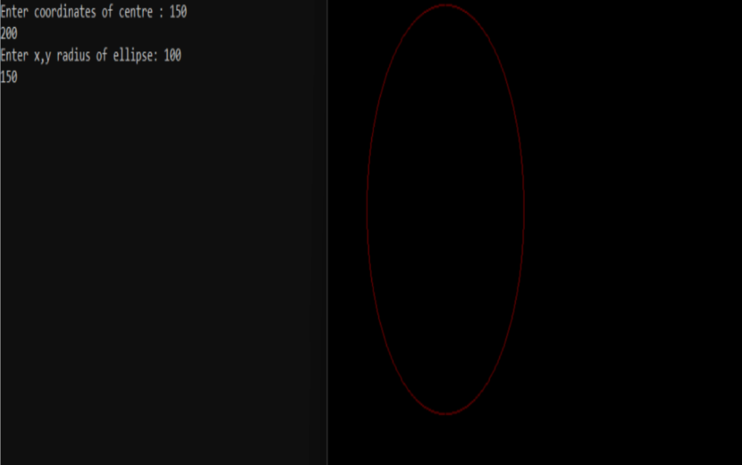

**LAB ASSIGNMENT NO. 06**

**QUESTION:- WAP to implement the Boundary fill algorithm.**

**CODE:**

import pygame

WHITE = (255, 255, 255, 255)

RED = (255, 0, 0, 255)

BLACK = (0, 0, 0, 255)

YELLOW = (255, 255, 0, 255)

def put_pixel(surface, p, color):

surface.set_at(p, color)

def boundary_fill(surface, p, fill_color, boundary_color):

'''4-way boundary fill'''

if surface.get_at(p) != boundary_color and surface.get_at(p) != fill_color:

put_pixel(surface, p, fill_color)

dx = [0, 1, 0, -1]

dy = [-1, 0, 1, 0]

for i in range(len(dx)):

boundary_fill(surface, (p[0] + dx[i], p[1] + dy[i]), fill_color, boundary_color)

def main():

pygame.init()

screen = pygame.display.set_mode((600, 200))

pygame.display.set_caption('2K19/CO/394-Sundeep Chand: Boundary Fill Algorithm')

star_coordinates = [

(300, 100),

(290, 120),

(270, 120),

(285, 130),

(280, 140),

(300, 135),

(320, 140),

(315, 130),

(330, 120),

(310, 120),

]

pygame.draw.polygon(screen, RED, star_coordinates, 2)

boundary_fill(screen, (300, 110), YELLOW, RED)

pygame.display.flip()

clock = pygame.time.Clock()

quit = False

while not quit:

for event in pygame.event.get():

if event.type == pygame.QUIT:

quit = True

clock.tick(60)

if __name__ == '__main__':

main()

**OUTPUT:**

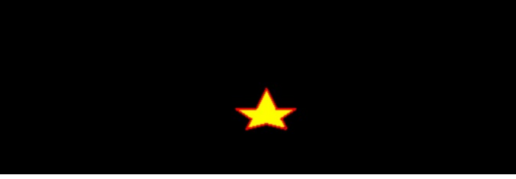

**LAB ASSIGNMENT NO. 07**

**QUESTION:- WAP to implement the Flood fill algorithm.**

**CODE:**

import pygame

WHITE = (255, 255, 255, 255)

RED = (255, 0, 0, 255)

BLACK = (0, 0, 0, 255)

YELLOW = (255, 255, 0, 255)

SCREEN_WIDTH = 600

SCREEN_HEIGHT = 200

def put_pixel(surface, p, color):

surface.set_at(p, color)

def flood_fill(surface, p, fill_color, prev_color=None):

'''4-way flood fill'''

if p[0] < 0 or p[1] < 0 or p[0] > SCREEN_WIDTH or p[1] > SCREEN_HEIGHT:

return

if prev_color == None:

prev_color = surface.get_at(p)

if surface.get_at(p) == prev_color:

put_pixel(surface, p, fill_color)

dx = [0, 1, 0, -1]

dy = [-1, 0, 1, 0]

for i in range(len(dx)):

flood_fill(surface, (p[0] + dx[i], p[1] + dy[i]), fill_color, prev_color)

def main():

pygame.init()

screen = pygame.display.set_mode((SCREEN_WIDTH, SCREEN_HEIGHT))

pygame.display.set_caption('2K19/CO/394-Sundeep Chand: Flood Fill Algorithm')

star_coordinates = [

(300, 100),

(290, 120),

(270, 120),

(285, 130),

(280, 140),

(300, 135),

(320, 140),

(315, 130),

(330, 120),

(310, 120),

]

pygame.draw.polygon(screen, RED, star_coordinates, 2)

flood_fill(screen, (300, 110), YELLOW)

# put_pixel(screen, (300, 110), WHITE)

pygame.display.flip()

clock = pygame.time.Clock()

quit = False

while not quit:

for event in pygame.event.get():

if event.type == pygame.QUIT:

quit = True

clock.tick(60)

if __name__ == '__main__':

main()

**OUTPUT:**

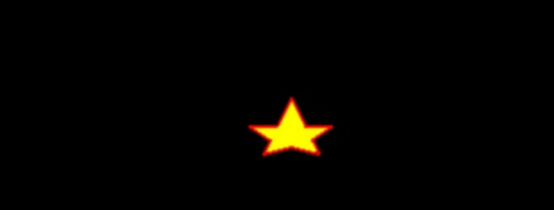

**LAB ASSIGNMENT NO. 08**

**QUESTION:- WAP to implement the Translation an object.**

**CODE:**

#include <iostream.h>

#include <conio.h>

#include <graphics.h>

void main()

{

int gd=DETECT,gm,x1,x2,y1,y2,tx,ty;

initgraph(&gd,&gm,(char*)"");

cout<<"Enter the first co-ordinate of a line:";

cin>>x1>>y1;

cout<<"Enter the second co-ordinate of a line:";

cin>>x2>>y2;

line(x1,y1,x2,y2);

cout<<"Enter the translation vector:";

cin>>tx>>ty;

setcolor(RED);

x1=x1+tx;

y1=y1+ty;

x2=x2+tx;

y2=y2+ty;

line(x1,y1,x2,y2);

getch();

closegraph();

}

**OUTPUT:**

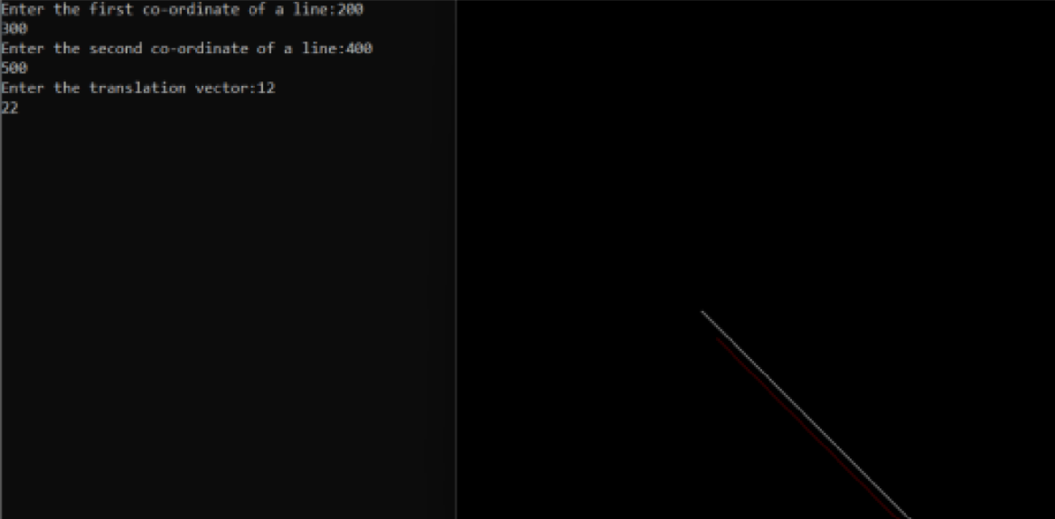

**LAB ASSIGNMENT NO. 09**

**QUESTION:- WAP to implement the Rotation an object.**

**CODE:**

#include <iostream>

#include <graphics.h>

#include <cmath>

using namespace std;

typedef struct {

float x;

float y;

float z;

}Point;

Point points;

float temp = 0;

void showPoint(){

cout<<"("<<points.x<<","<<points.y<<","<<points.z<<")"<<endl;

}

void translate(float tx, float ty, float tz){

points.x += tx;

points.y += ty;

points.z += tz;

cout<<"After Translation, new point is :";

showPoint();

}

void rotatex(float angle){

angle = angle * M_PI / 180.0;

temp = points.y;

points.y = points.y * cos(angle) - points.z * sin(angle);

points.z = temp * sin(angle) + points.z * cos(angle);

cout<<"After rotation about x, new point is: ";

showPoint();

}

void rotatey(float angle){

angle = (angle * M_PI) / 180.0;

temp = points.z;

points.z = points.z * cos(angle) - points.x * sin(angle);

points.x = temp * sin(angle) + points.x * cos(angle);

cout<<"After rotation about y, new point is: ";

showPoint();

}

void rotatez(float angle){

angle = angle * M_PI / 180.0;

temp = points.x;

points.x = points.x * cos(angle) - points.y * sin(angle);

points.y = temp * sin(angle) + points.y *cos(angle);

cout<<"After rotation about z, new point is: ";

showPoint();

}

void scale(float sf, float xf, float yf, float zf){

points.x = points.x * sf + (1 - sf) * xf;

points.y = points.y * sf + (1 - sf) * yf;

points.z = points.z * sf + (1 - sf) * zf;

cout<<"After scaling, new point is: ";

showPoint();

}

int main()

{

float tx = 0, ty = 0, tz = 0;

float sf = 0, xf = 0, yf = 0, zf = 0;

int choose;

float angle;

cout<<"\n\nEnter the initial point you want to transform:";

cin>>points.x>>points.y>>points.z;

cout<<"Choose the following: "<<endl;

cout<<"1. Translate"<<endl;

cout<<"2. Rotate about X axis"<<endl;

cout<<"3. Rotate about Y axis"<<endl;

cout<<"4. Rotate about Z axis"<<endl;

cout<<"5. Scale"<<endl;

cin>>choose;

switch(choose){

case 1:

cout<<"Enter the value of tx, ty and tz: ";

cin>>tx>>ty>>tz;

translate(tx, ty, tz);

break;

case 2:

cout<<"Enter the angle: ";

cin>>angle;

rotatex(angle);

break;

case 3:

cout<<"Enter the angle: ";

cin>>angle;

rotatey(angle);

break;

case 4:

cout<<"Enter the angle: ";

cin>>angle;

rotatez(angle);

break;

case 5:

cout<<"Enter the value of sf, xf, yf and zf: ";

cin>>sf>>xf>>yf>>zf;

scale(sf, xf, yf, zf);

break;

default:

break;

}

return 0;

}

**OUTPUT:**

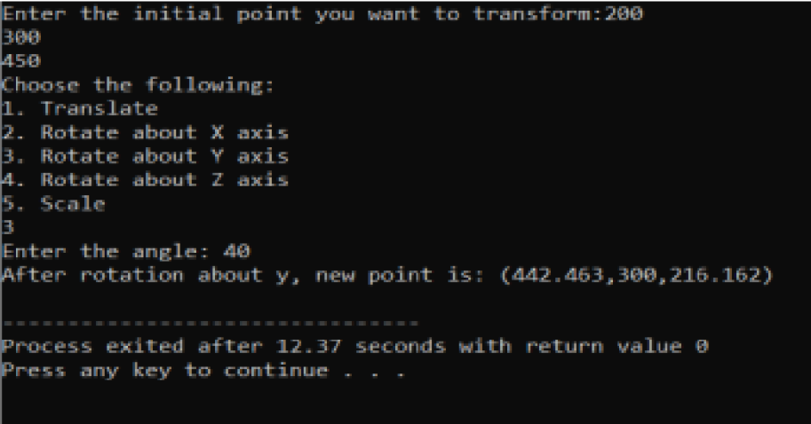

**LAB ASSIGNMENT NO. 10**

**QUESTION:- WAP to implement the Scaling an object.**

**CODE:**

#include <iostream>

#include <conio.h>

#include <graphics.h>

int main()

{

int gd=DETECT,gm;

float x1,y1,x2,y2,sx,sy;

initgraph(&gd,&gm,(char*)"");

std::cout<<"name:sristi mitra\n\n";

std::cout<<"roll 2k19.co.389\n\n";

std::cout<<"SCALING OF A LINE\n";

std::cout<<"Enter the first coordinate of a line:";

std::cin>>x1>>y1;

std::cout<<"Enter the second coordinate of a line:";

std::cin>>x2>>y2;

line(x1,y1,x2,y2);

std::cout<<"Enter the scaling factor:";

std::cin>>sx>>sy;

setcolor(RED);

x1=x1*sx;

y1=y1*sy;

x2=x2*sx;

y2=y2*sy;

line(x1,y1,x2,y2);

getch();

closegraph();

}

**OUTPUT:**

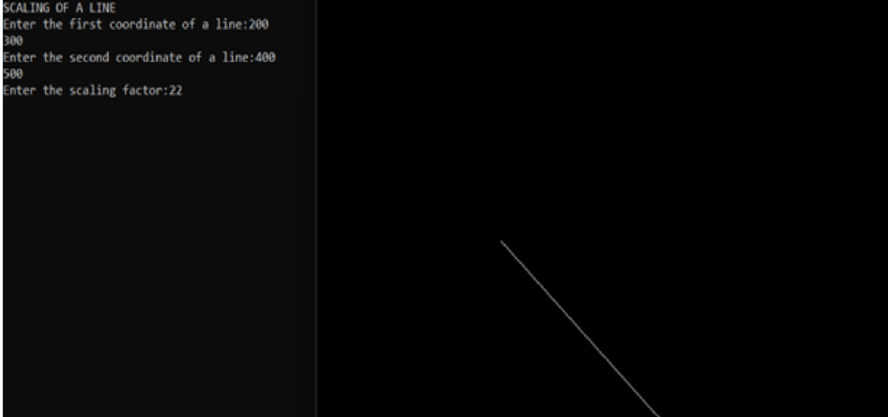

**LAB ASSIGNMENT NO. 11**

**QUESTION:- WAP to implement Reflection an object.**

**CODE:**

#include <iostream.h>

#include <conio.h>

#include <graphics.h>

#include <math.h>

void main()

{

int gd=DETECT,gm;

initgraph(&gd,&gm,"C:\\Tc\\BGI");

int a=getmaxx();

int b=getmaxy();

int y=b⁄2;

int x=a⁄2;

line(x,0,x,b);

line(0,y,a,y);

int x1=x+100;

int y1=y-100;

int x2=x+150;

int y2=y-150;

line(x2,y2,x1,y1);

line(x2,y+150,x1,y+100);

line(x-100,y+100,x-200,y+100);

line(x-150,y+150,x-200,y+100);

line(x-100,y+100,x-150,y+150);

line(x-100,y-100,x-150,y-150);

line(x-150,y-150,x-200,y-100);

line(x-200,y-100,x-100,y-100);

getch();

closegraph();

}

**OUTPUT:**

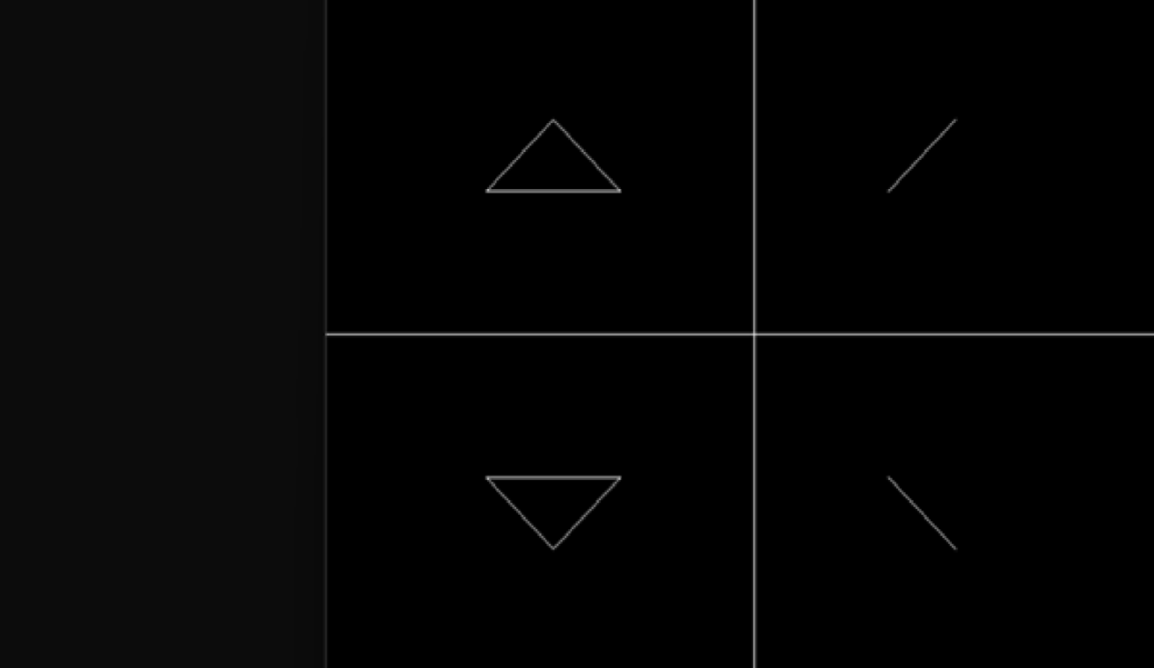

**LAB ASSIGNMENT NO. 12**

**QUESTION:- Write a program to implement Cohen Sutherland Line Clipping Algorithm.**

**CODE:**

#include <bits/stdc++.h>

#include <graphics.h>

using namespace std;

int xmin, xmax, ymin, ymax;

struct lines {

int x1, y1, x2, y2;

};

int sign(int x)

{

if (x > 0)

return 1;

else

return 0;

}

void clip(struct lines mylines)

{

int bits[4], bite[4], i, var;

setcolor(RED);

bits[0] = sign(xmin - mylines.x1);

bite[0] = sign(xmin - mylines.x2);

bits[1] = sign(mylines.x1 - xmax);

bite[1] = sign(mylines.x2 - xmax);

bits[2] = sign(ymin - mylines.y1);

bite[2] = sign(ymin - mylines.y2);

bits[3] = sign(mylines.y1 - ymax);

bite[3] = sign(mylines.y2 - ymax);

string initial = "", end = "", temp = "";

for (i = 0; i < 4; i++) {

if (bits[i] == 0)

initial += '0';

else

initial += '1';

}

for (i = 0; i < 4; i++) {

if (bite[i] == 0)

end += '0';

else

end += '1';

}

float m = (mylines.y2 - mylines.y1) / (float)(mylines.x2 - mylines.x1);

float c = mylines.y1 - m * mylines.x1;

if (initial == end && end == "0000") {

line(mylines.x1, mylines.y1, mylines.x2, mylines.y2);

return;

}

else {

for (i = 0; i < 4; i++) {

int val = (bits[i] & bite[i]);

if (val == 0)

temp += '0';

else

temp += '1';

}

if (temp != "0000")

return;

for (i = 0; i < 4; i++) {

if (bits[i] == bite[i])

continue;

if (i == 0 && bits[i] == 1) {

var = round(m * xmin + c);

mylines.y1 = var;

mylines.x1 = xmin;

}

if (i == 0 && bite[i] == 1) {

var = round(m * xmin + c);

mylines.y2 = var;

mylines.x2 = xmin;

}

if (i == 1 && bits[i] == 1) {

var = round(m * xmax + c);

mylines.y1 = var;

mylines.x1 = xmax;

}

if (i == 1 && bite[i] == 1) {

var = round(m * xmax + c);

mylines.y2 = var;

mylines.x2 = xmax;

}

if (i == 2 && bits[i] == 1) {

var = round((float)(ymin - c) / m);

mylines.y1 = ymin;

mylines.x1 = var;

}

if (i == 2 && bite[i] == 1) {

var = round((float)(ymin - c) / m);

mylines.y2 = ymin;

mylines.x2 = var;

}

if (i == 3 && bits[i] == 1) {

var = round((float)(ymax - c) / m);

mylines.y1 = ymax;

mylines.x1 = var;

}

if (i == 3 && bite[i] == 1) {

var = round((float)(ymax - c) / m);

mylines.y2 = ymax;

mylines.x2 = var;

}

bits[0] = sign(xmin - mylines.x1);

bite[0] = sign(xmin - mylines.x2);

bits[1] = sign(mylines.x1 - xmax);

bite[1] = sign(mylines.x2 - xmax);

bits[2] = sign(ymin - mylines.y1);

bite[2] = sign(ymin - mylines.y2);

bits[3] = sign(mylines.y1 - ymax);

bite[3] = sign(mylines.y2 - ymax);

}

initial = "", end = "";

for (i = 0; i < 4; i++) {

if (bits[i] == 0)

initial += '0';

else

initial += '1';

}

for (i = 0; i < 4; i++) {

if (bite[i] == 0)

end += '0';

else

end += '1';

}

if (initial == end && end == "0000") {

line(mylines.x1, mylines.y1, mylines.x2, mylines.y2);

return;

}

else

return;

}

}

int main()

{

int gd = DETECT, gm;

xmin = 40;

xmax = 100;

ymin = 40;

ymax = 80;

initgraph(&gd, &gm, NULL);

line(xmin, ymin, xmax, ymin);

line(xmax, ymin, xmax, ymax);

line(xmax, ymax, xmin, ymax);

line(xmin, ymax, xmin, ymin);

struct lines mylines[4];

mylines[0].x1 = 30;

mylines[0].y1 = 65;

mylines[0].x2 = 55;

mylines[0].y2 = 30;

mylines[1].x1 = 60;

mylines[1].y1 = 20;

mylines[1].x2 = 100;

mylines[1].y2 = 90;

mylines[2].x1 = 60;

mylines[2].y1 = 100;

mylines[2].x2 = 80;

mylines[2].y2 = 70;

mylines[3].x1 = 85;

mylines[3].y1 = 50;

mylines[3].x2 = 120;

mylines[3].y2 = 75;

for (int i = 0; i < 4; i++) {

line(mylines[i].x1, mylines[i].y1,

mylines[i].x2, mylines[i].y2);

delay(1000);

}

for (int i = 0; i < 4; i++) {

clip(mylines[i]);

delay(1000);

}

delay(4000);

getch();

closegraph();

return 0;

}

**OUTPUT:**

